DICTADOS MELÓDICOS: escala de Mi m

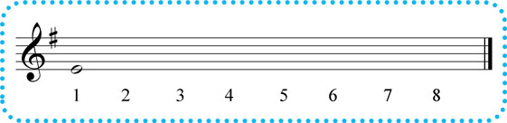

DICT. 1

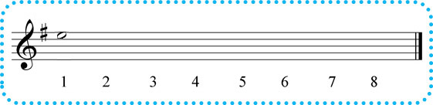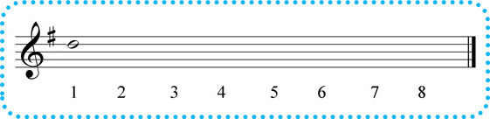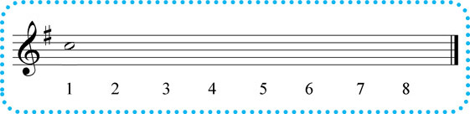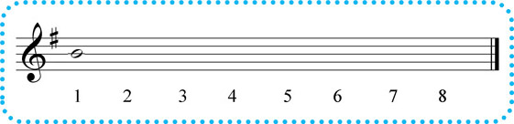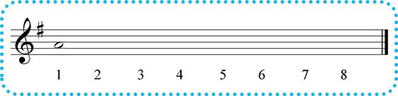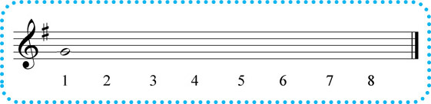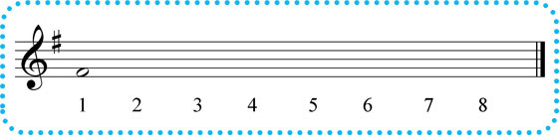

DICT. 9

DICT. 8

DICT. 7

DICT. 6

DICT. 5

DICT. 4

DICT. 3

DICT. 2